Data
xs= [107.608 108.632 109.773 110.929 112.075 113.27 115.094 116.219 117.388
118.734 120.445 121.95 123.366 125.368 127.852 130.081]
ys= [60.323 61.122 60.171 61.187 63.221 63.639 64.989 63.761 66.019 67.857
68.169 66.513 68.655 69.564 69.331 70.551]

0.48487809831571843

0.48487809831571843 8.380674183375078

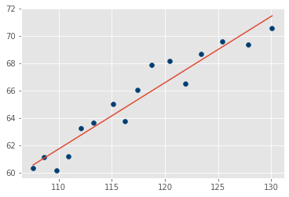 Trained value

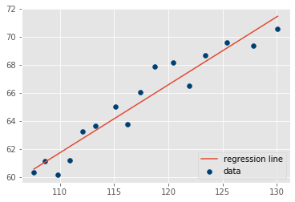 Predicted value

